**PROJECT**

**2nd Increment Report**

**on**

**“APP REVIEWER”**

**By**

**Vinil Kumar Kamigari**

**Sumanth Koushik Kalli**

**Alekhya Boyapati**

**Importing Existing Services:**

The existing services used in this increment are HTML language, Javascript and cascading style sheets (CSS) for implementing the user interface. In future we are going to use the description and ratings of apps from this site (<https://play.google.com/store/apps?hl=en>).

**Detail Design of Services:**

In this design of mobile interface we created the required home page for selecting different categories of apps, the user wants to view. Basically, whenever user presses on particular category all the apps related to that category will be displayed. We have just created the category box and are going to build the app selection for viewing the reviews in upcoming increments.

**Implementation**

**Implementation of services:** We created home screen for our project and also the selection of category for sorting the apps and to provide user with easy access. However we are going to use Hadoop for analyzing number of users downloaded a particular app, their reviews about the apps in the further increments.

**Generate your datasets:** App data is collected from the Google Play store and then arranged into the .txt files. We have created the different categories that are available in apps and are going to create datasets for each category. So, whenever the user presses the app belonging to the category then the details about the app are being analyzed using Hadoop and then displayed to the user.

**Implementation of user interface (Mobile Apps):** Here we implemented user interface using the HTML language and Cascading style sheets. The initial home screen is developed in this project for this increment. Further modules will be added in next increments.

**Report:** In our project “APP REVIEWER” we have developed the front end using HTML, JavaScript and CSS as part of First increment.

We added features which include “New Releases”, which allows the user to get the list of recently released apps and then we also added a feature which allows the user to select a particular category in selecting an application from the huge pool set of Apps.

We also included “Recommended apps for you”, which recommends user with apps.

We have used the Google’s Play store to get the information about Apps and also redirected the apps to that site if user requests information for time being.

**Step 1:** Here the Best New Apps can be seen and when the user just selects any of the app he is interested in then it redirects to the Google Play Store and he can download and read more number of reviews before downloading the app.

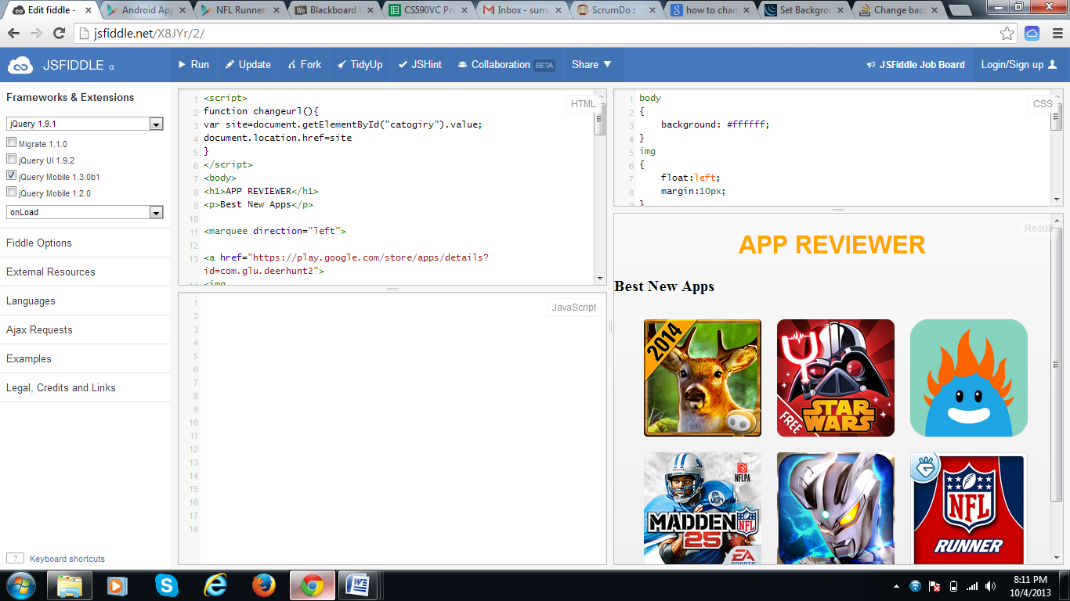

**Step 2:** Here is the image which shows the recommended apps for a particular user based on his interests.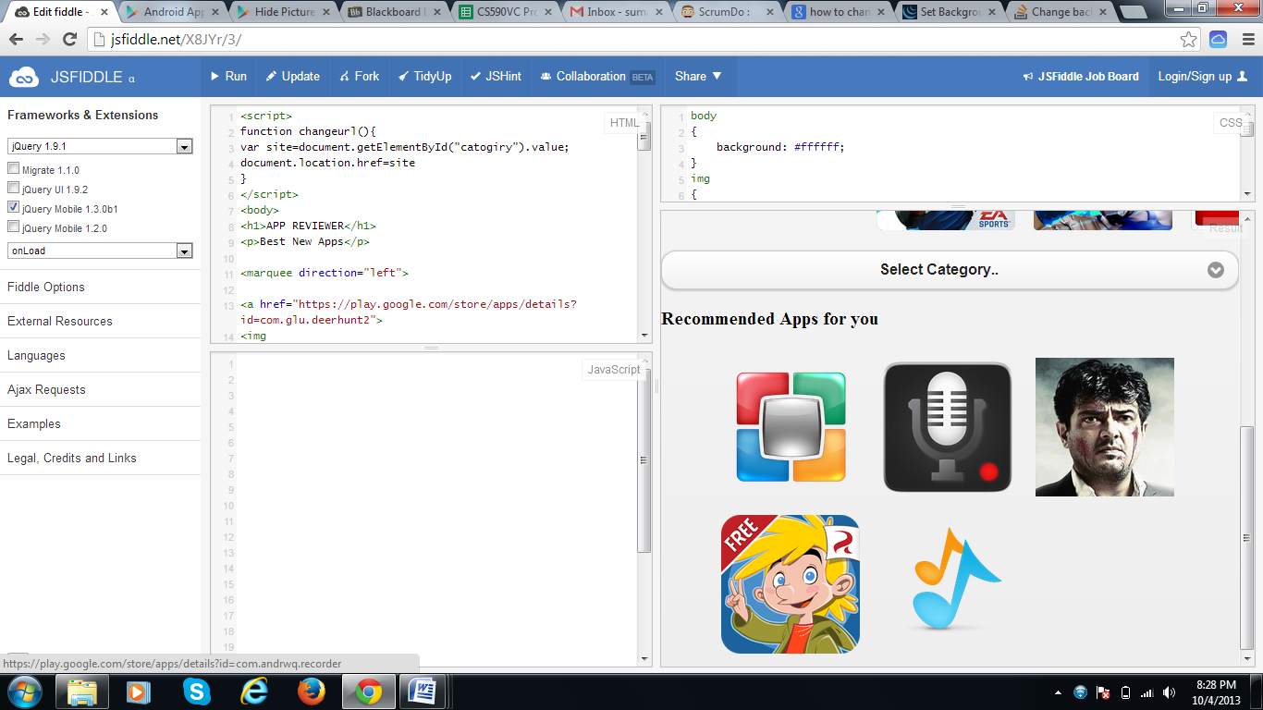

**Implementation Status Report**

**Work Completed:**

* **Description:** In the second increment, we collected data about App’s [App Name, Average Rating of the app, Number of users rated 5, Number of users rated 4, Number of users rated 3, Number of users rated 2, Number of users rated 1, Reviews for the app]. Data about applications in various categories are collected into the .txt files.

We studied the Pig Scripting Language for converting our Java Program into Map Reduce jobs and invoking Hadoop.

* **Responsibility:**

**Data Collection:** Data about apps are collected from the Play store byAlekhya and Sumanth. The data collected includes App Name, Rating of the app, Number of users recommending the app, Number of users rated in 5,4,3,2,1 star rating, reviews of the app.

**Documentation:** Documentation for the 2nd increment has been prepared by Alekhya Boyapati and Sumanth Koushik Kalli.

* **Time Taken:** We spent 130 hours each for getting data, coding Java Program and learning Pig.
* **Contributions:**

**Sumanth:** Studying sources of Data, contacting organizations for getting Data, Part of HTML coding, providing styling using CSS and documentation.(40%)

**Alekhya:** Studying sources of Data, Part of HTML coding for User Interface and documentation. (40%)

**Vinil:** Studying about Pig (20%)

**Work to be completed:**

* **Description:** In the future increments, we are looking forward to write a java code to analyze data and then it has to be given to PIG for converting it to Map reduce jobs.
* **Responsibility:**

Bringing up a program for analyzing the obtained data will be shared by three of us equally. We three of ous will read about PIG.

* **Time Taken:** We estimate that we require around 120 hours each for an increment.

**Issues/Concerns:**

The major concern in this increment was collecting raw data. We haven’t got any API to access the dynamic data.